**Deployment package with dependencies**

To create the deployment package

1. Open a command prompt and create a my-demo-project project directory.

For example

mkdir my-demo-project

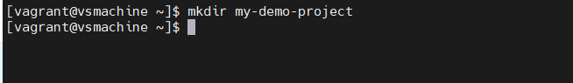

1. Navigate to the  project directory.

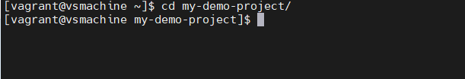

1. Copy the contents of the following sample Python code and save it in a new file

named lambda_function.py:

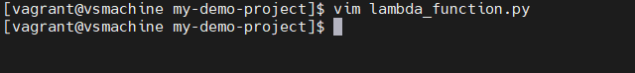

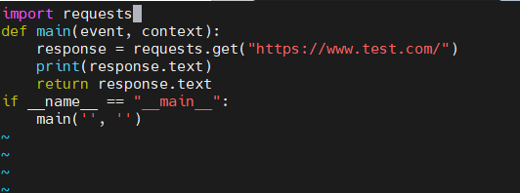

https://github.com/vishnuvs369/Aws-Python/blob/main/Aws-deploying-packages-with-depencies/lambda_function.py

Your directory structure look like this:

my-demo-project$

| lambda_function.py

4.Install the requests library to a new package directory.

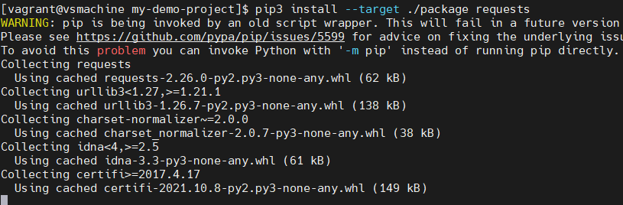

Pip3 install --target ./package requests

5. Create a deployment package with the installed library at the root.

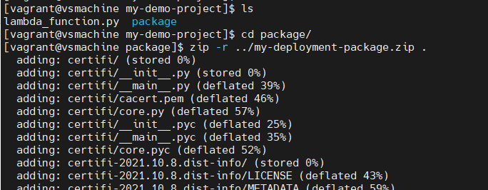

cd package

zip -r ../my-deployment-package.zip .

This generates a my-deployment-package.zip file in your project directory.

6. Add the lambda_function.py file to the root of the zip file.

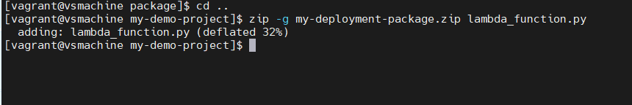

cd ..

zip -g my-deployment-package.zip lambda_function.py

7. Deploy your .zip file to the function

To deploy the new code to your function, you upload the new .zip file deployment package. You can use the Lambda console to upload a .zip file to the function.

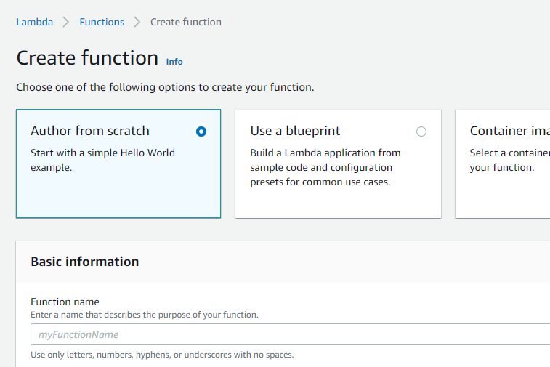

Go to Lambda console and create the function

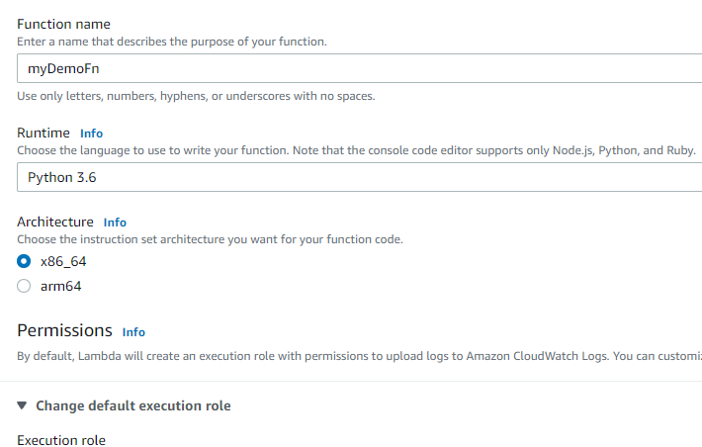

Now choose upload from zip file

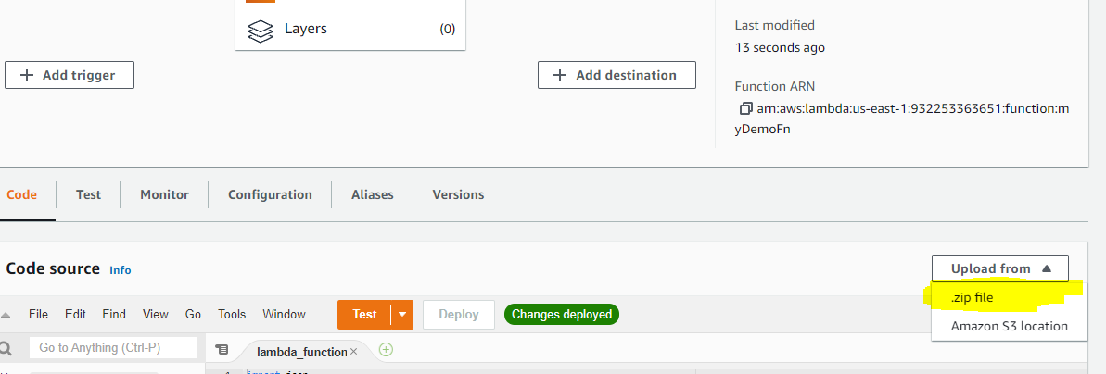

Upload the zipped file

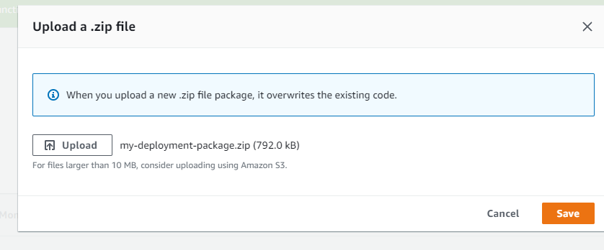

Our zipped file with required dependencies present there, now test the function

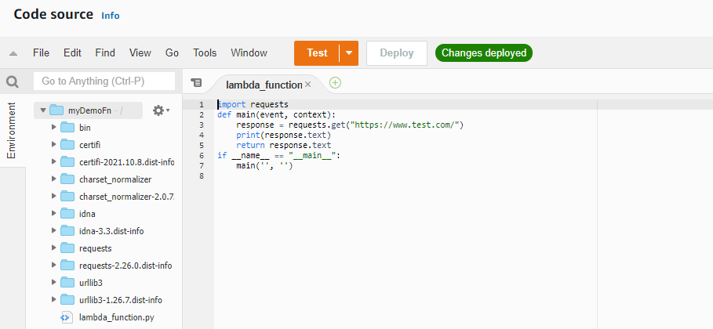

Before testing change the handler name in our runtime setting to main and save it

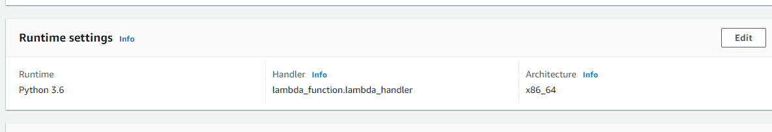

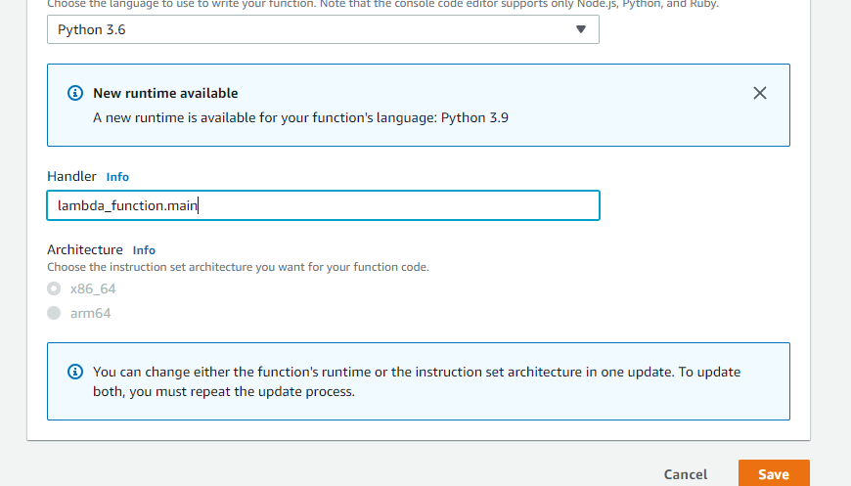

Now run the test, You can see our lambda function is executed and response is getting

